Air - Mates

We are blessed to share the air and land with many winged friends!
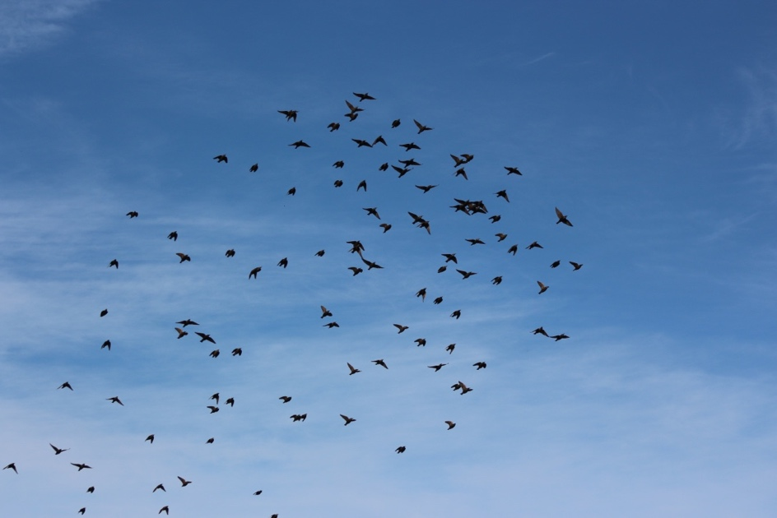
Hawks and Ravens! Great horned owls with young, birds whose flocks make amazing arial feats and patterns, keeping our eyes up and on the sky

With so many ….more photos will be added.
Here are some of the patterns in the air our winged friends created.
