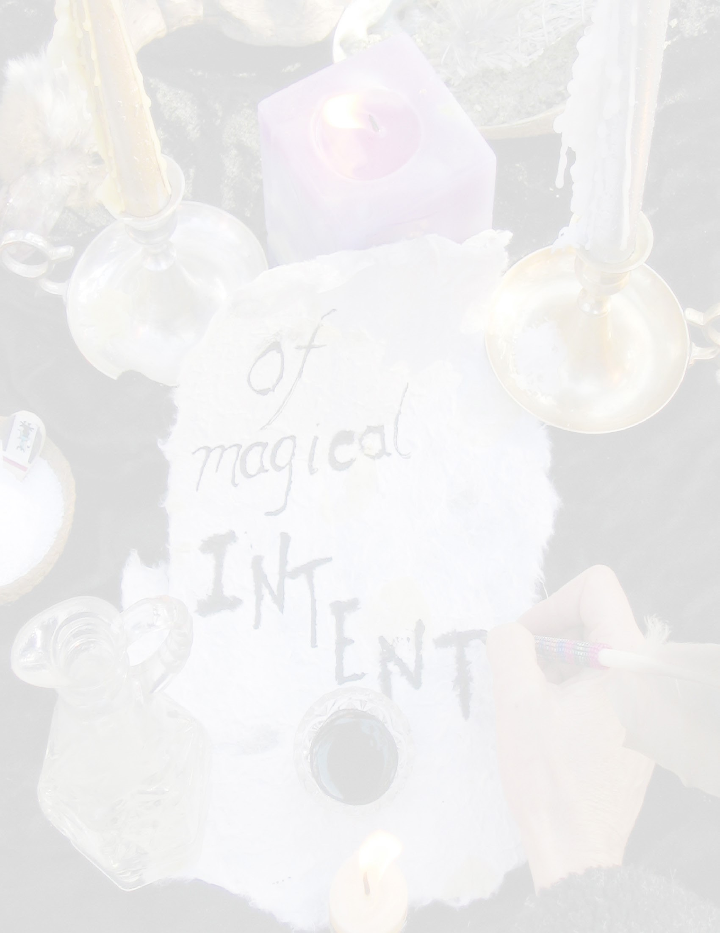

Ritual

Writing out your New Moon Intention

Opening sacred space

Smudging,

Wrting out the goal for the lunar cycle ahead.

Blessing it with the power four elements.

Gratefullness.

Closing sacred space.

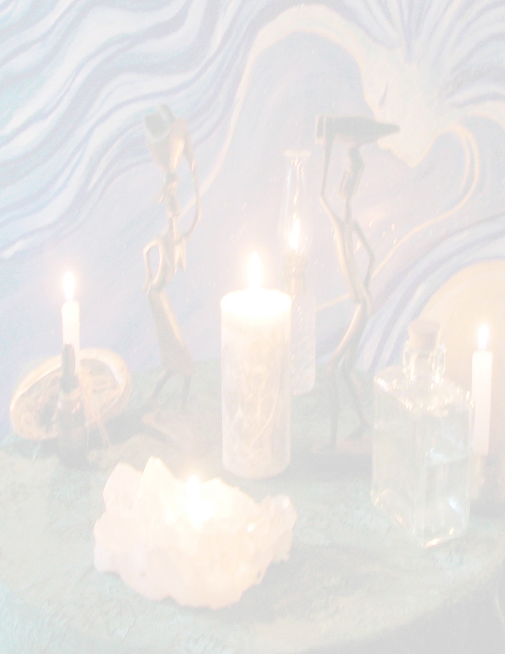

Ritual

Opening sacred space

Smudging,

Blessing your candle. Carving your Candle

Annointing your candle.

Lighting it up.

Closing sacred space.

Candle Magic

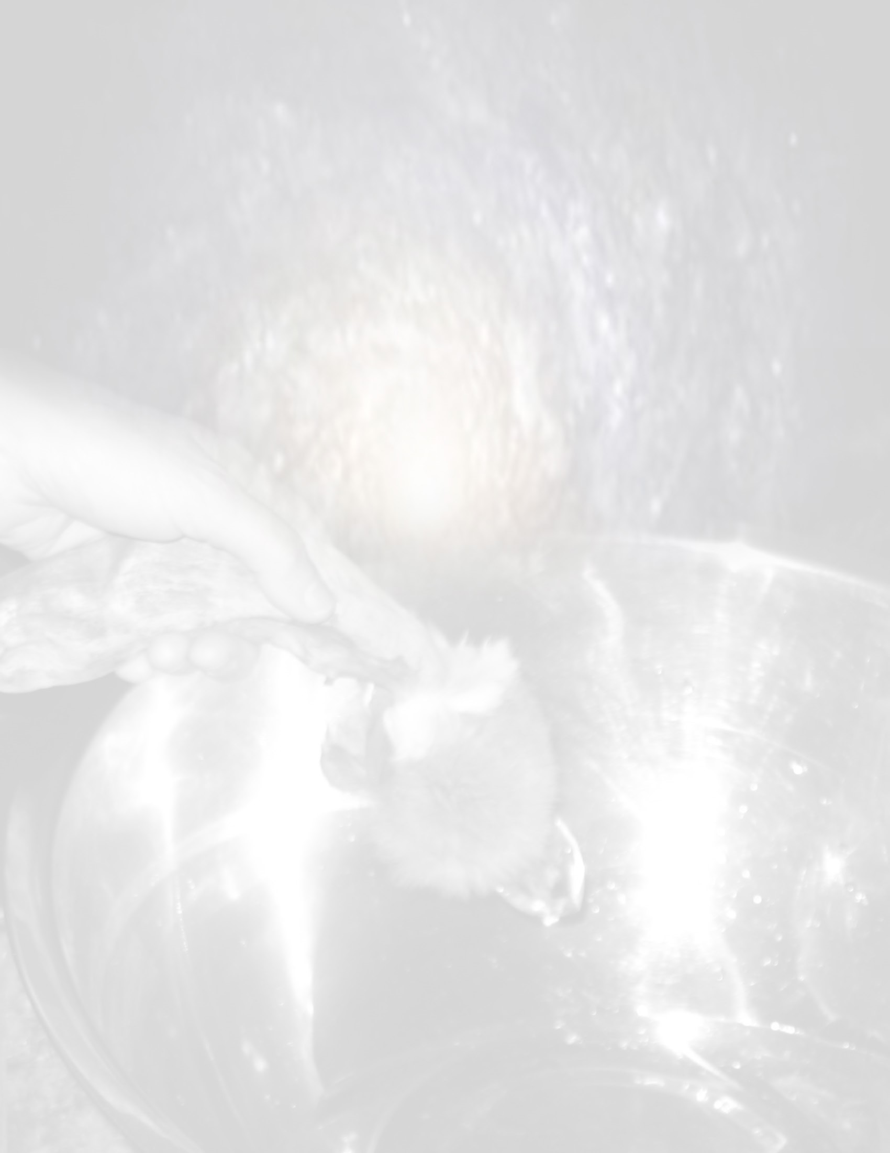

Ritual

Opening sacred space

Smudging,

Make Blessed Water.

Drawing down the moon

Blessing sacred items with the Full Moon.

Feasting.

Closing sacred space.

Making Full Moon - Blessed Water

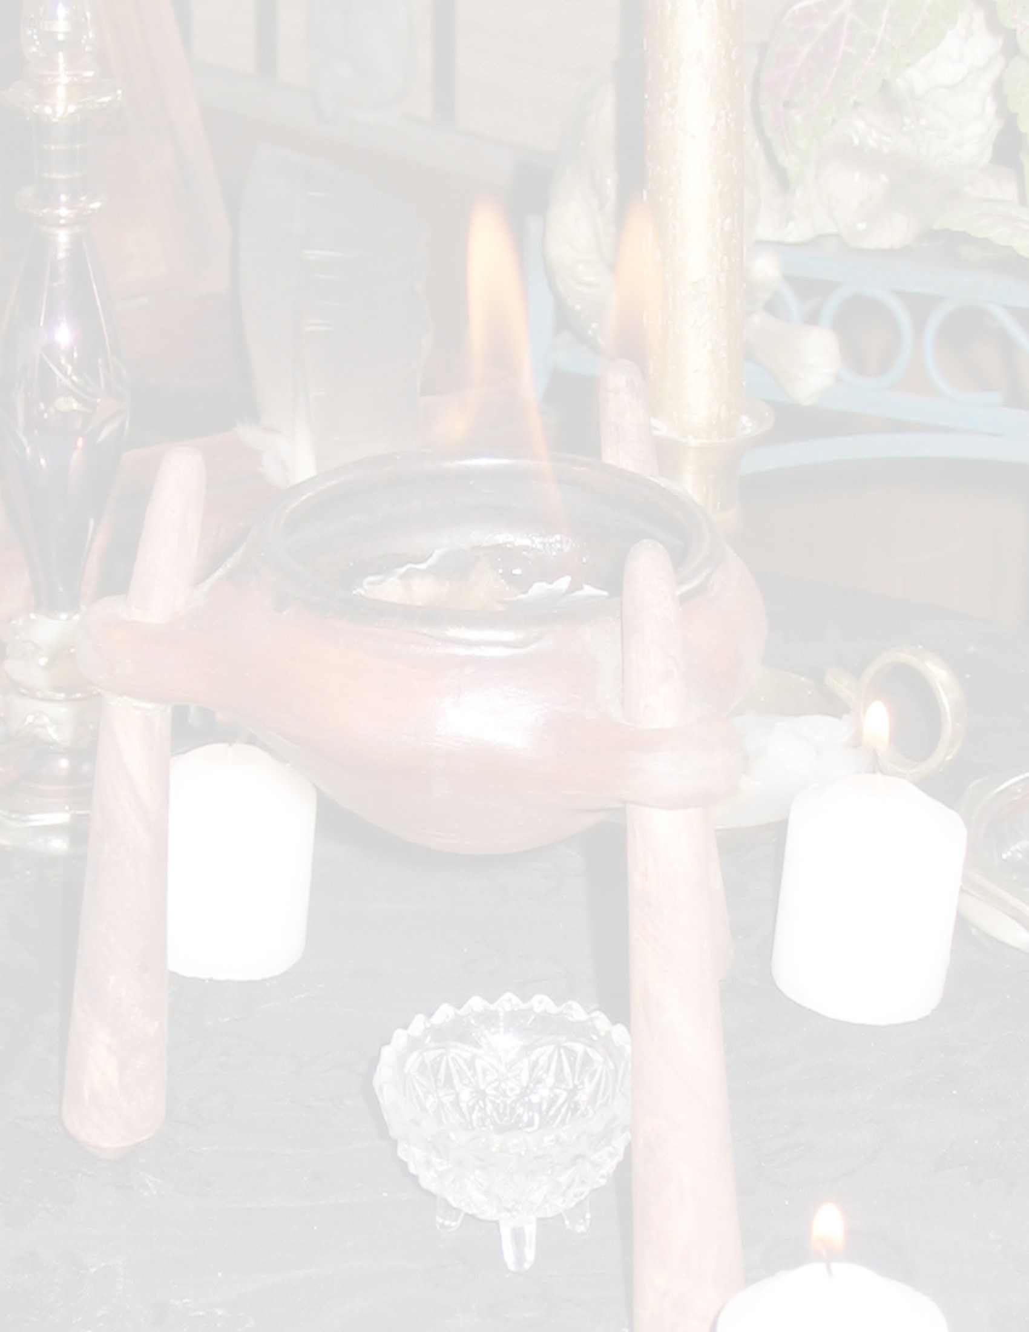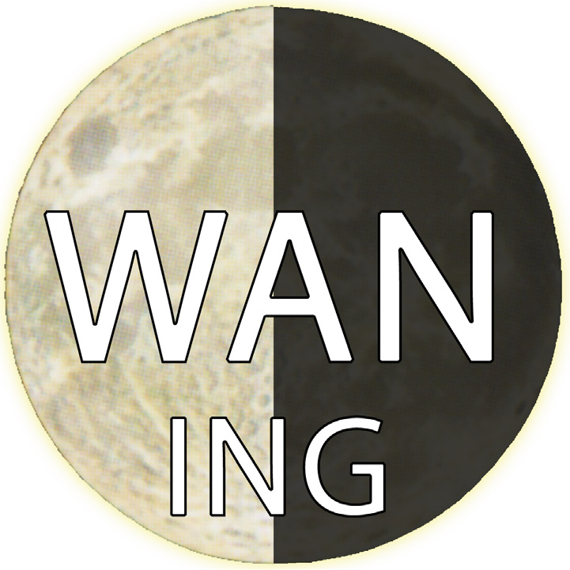

Ritual

Opening sacred space

Smudging,

Building a sacred fire with the elements.

Meditate with the fire,

burn away what does not serve you.

Cleaning and clearing.

Closing sacred space.

Fire Ceremony

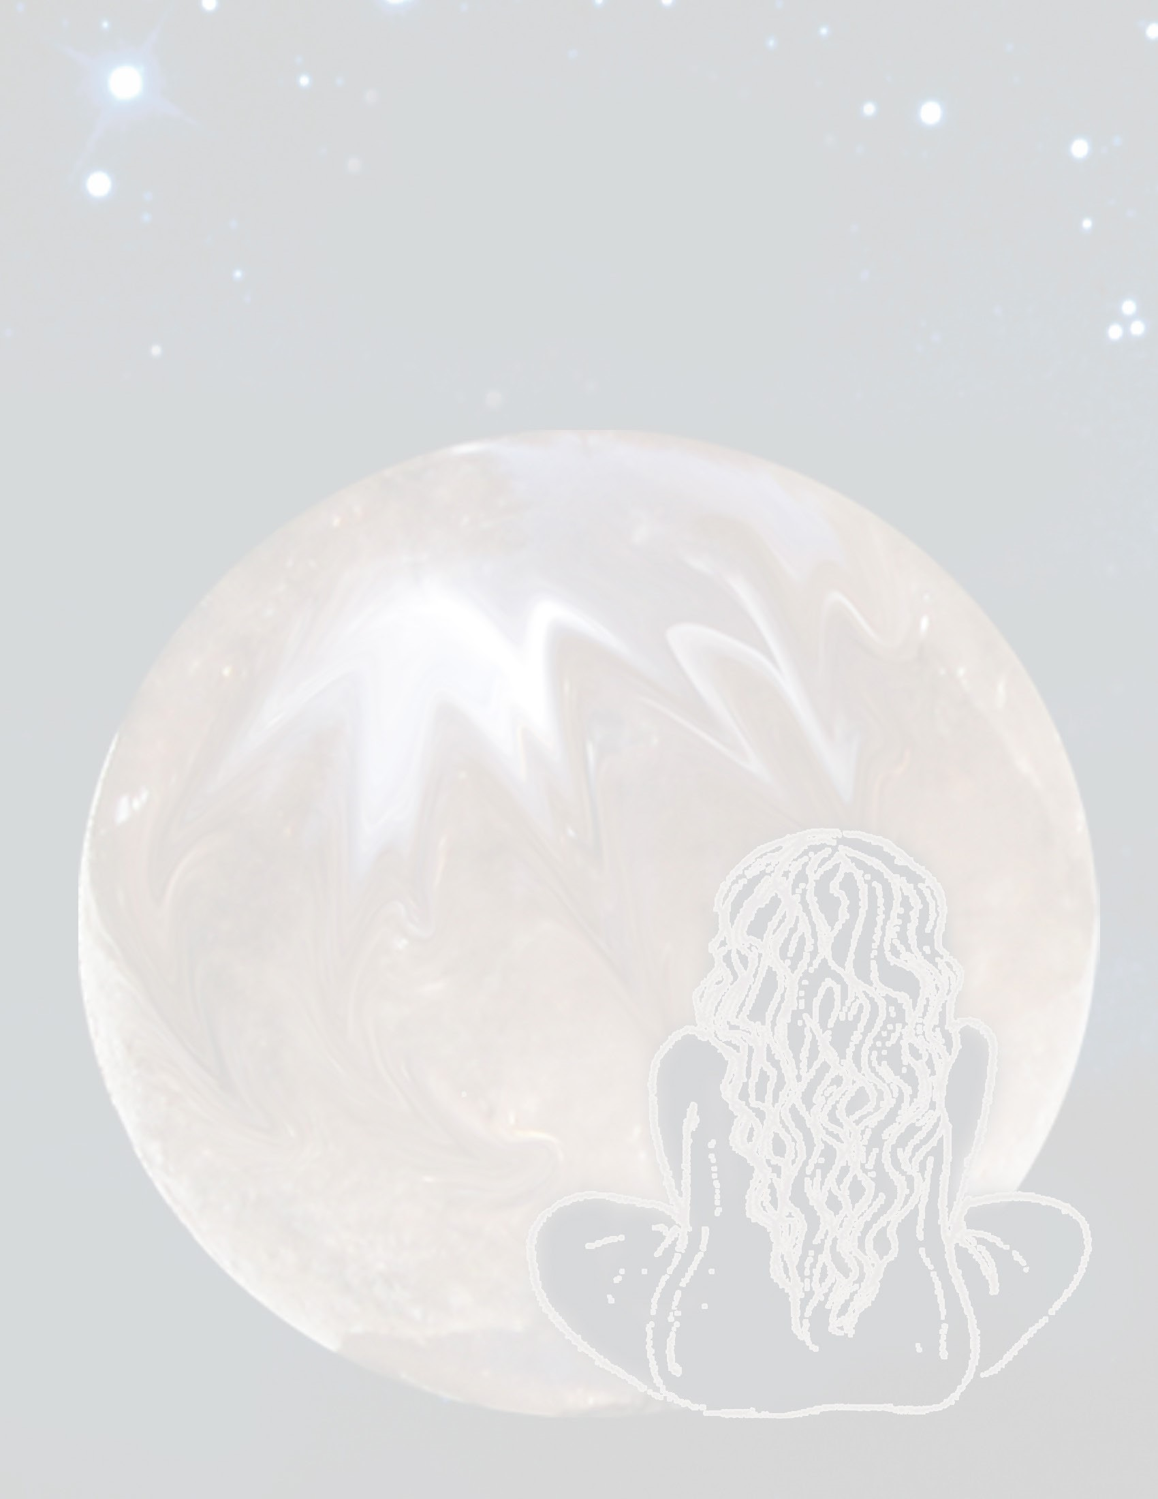

Ritual

Opening sacred space

Smudging,

Preparing to journey - Journey with the elements.

Record experience.

Closing sacred space.

Journeying