Canine Friends

Scionaka our wolf has been with us over 10 years and is as playful as a puppy!
She raised Nakoda the Second and loves to play with him.

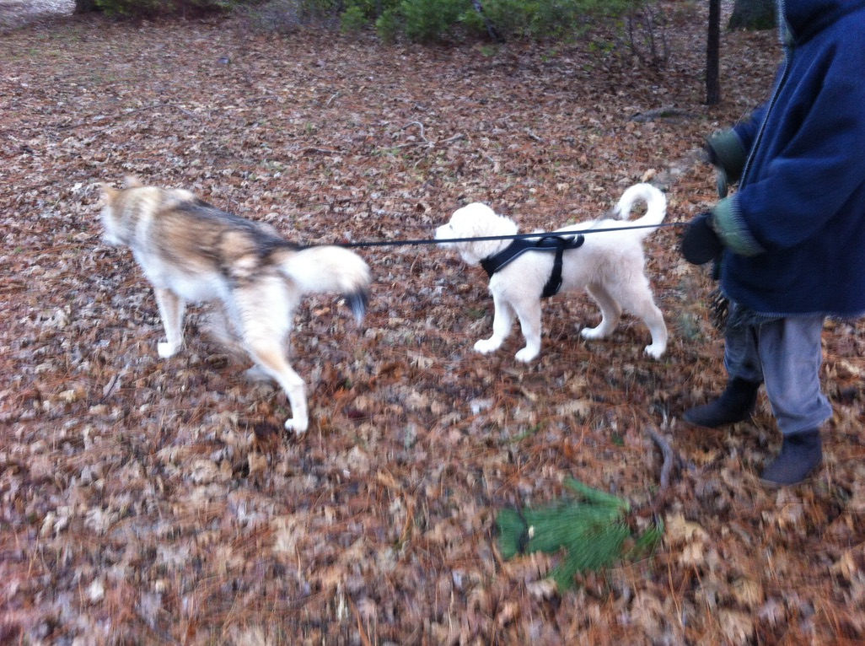
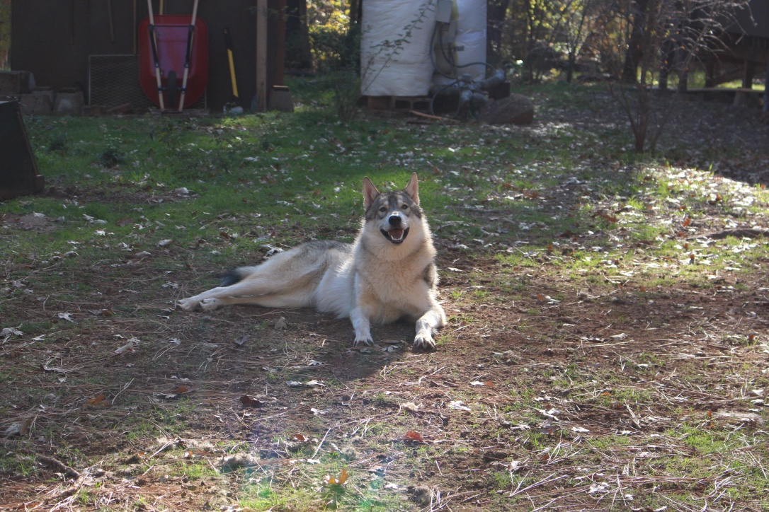
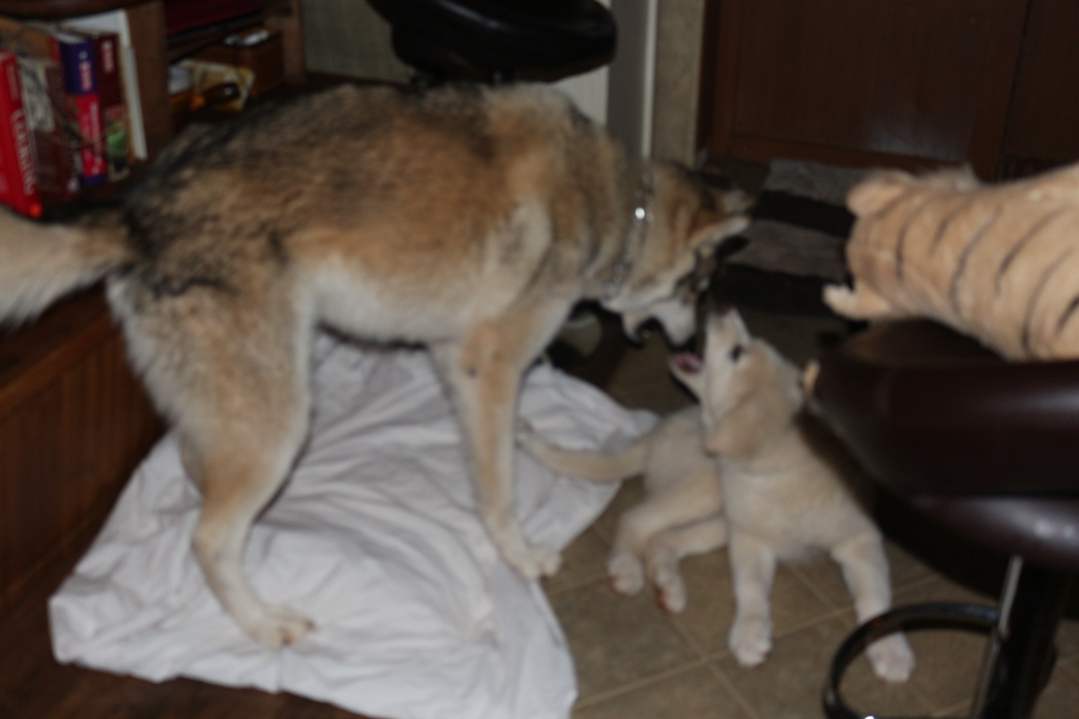
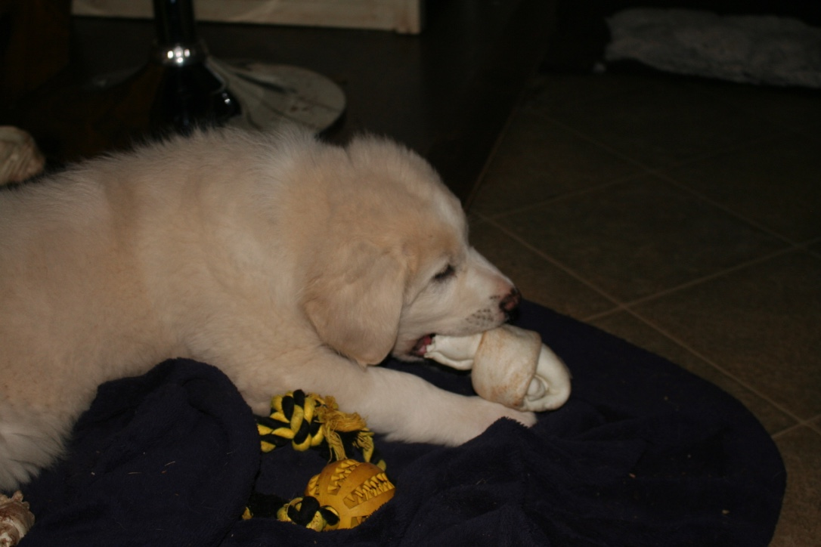
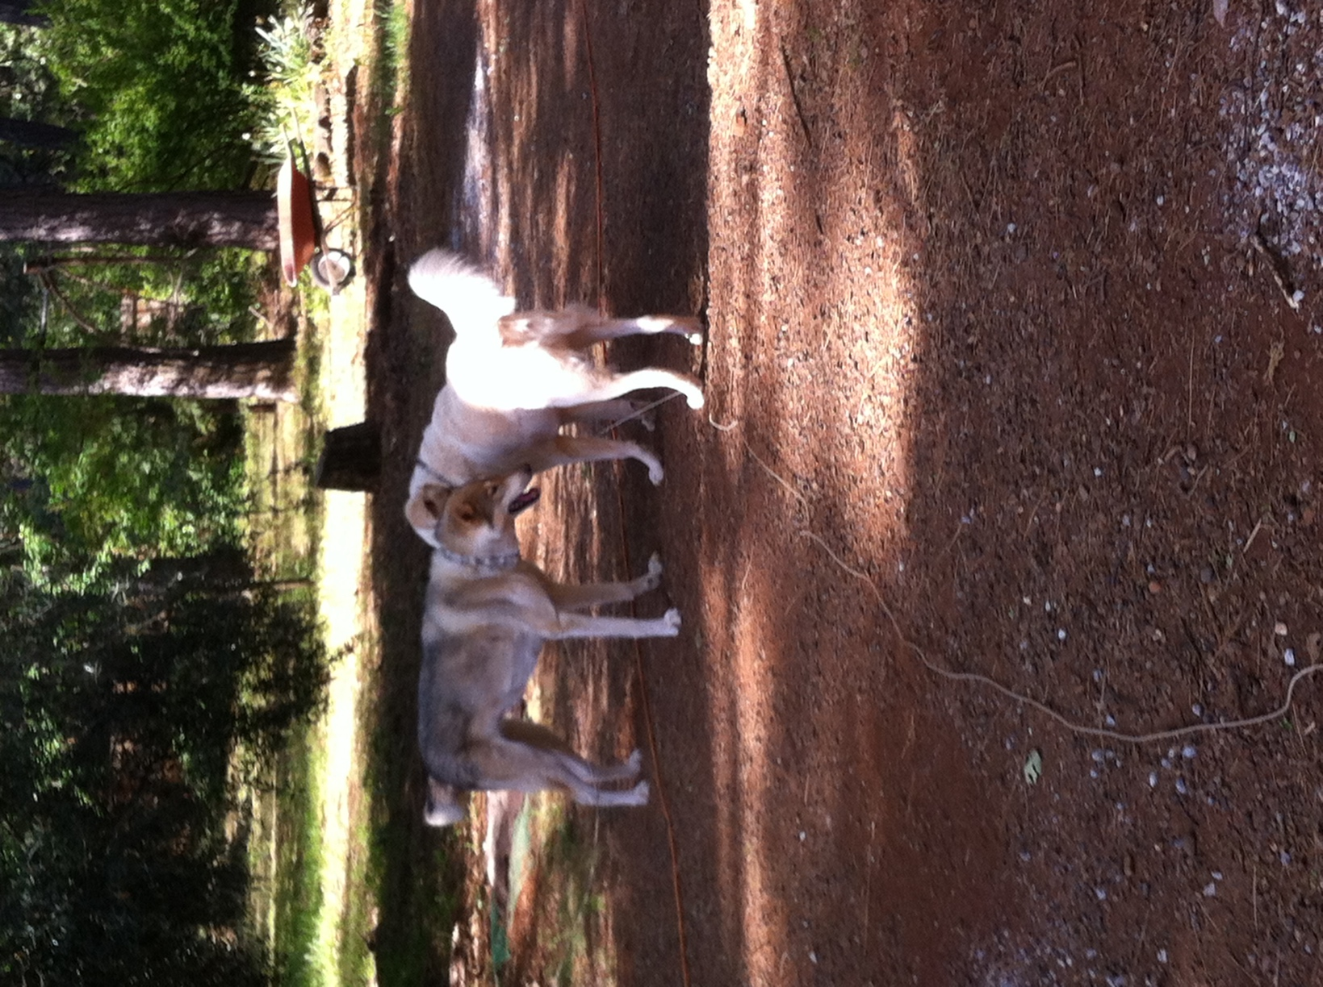
Nakoda the Second is our guardian dog who keeps watch over our herd, flock and everything that comes on the land. He has saved the lives of some barnyard friends

