Skunks

We found a litter of skunks on the land when we first moved to the sanctuary, cleaning up the land.
They are a hoot, just don’t get sprayed. They often stop by for a visit and are so cute and playful.
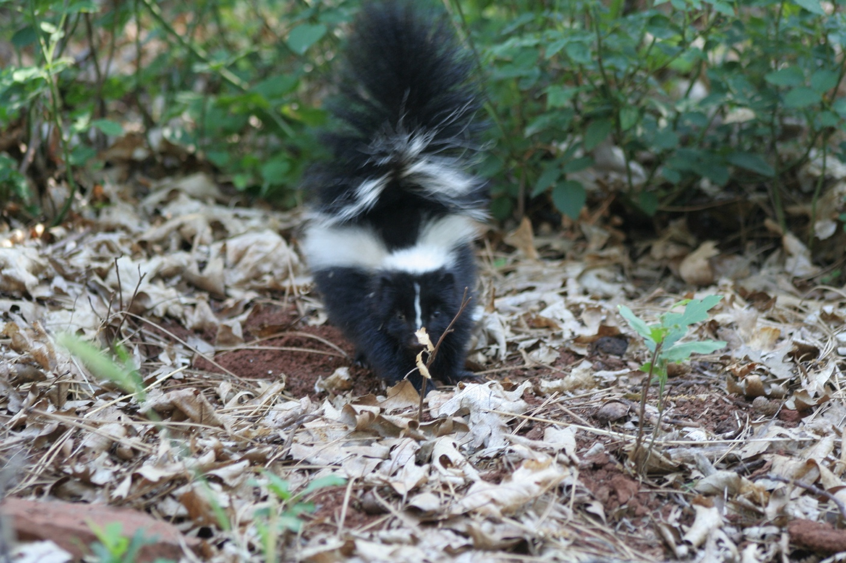
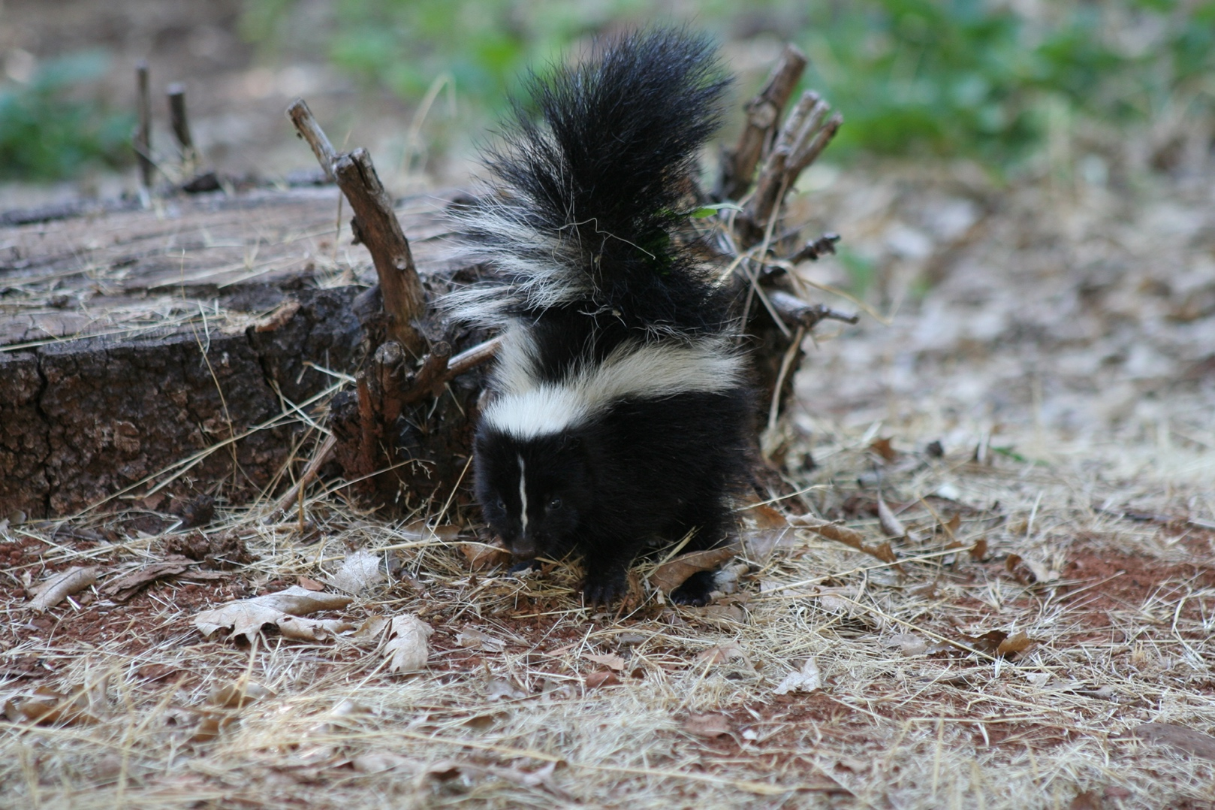
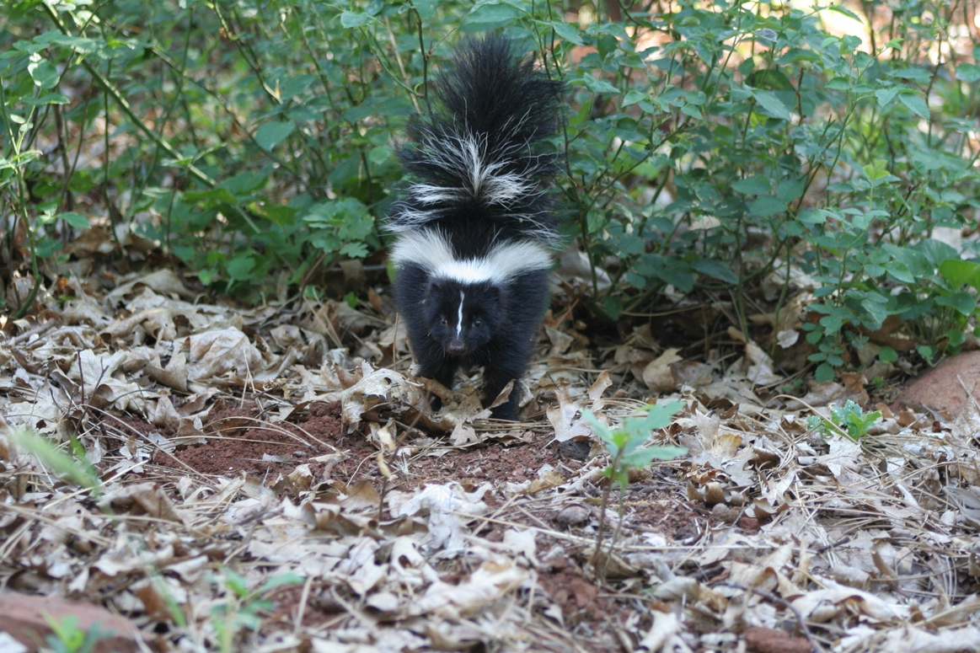
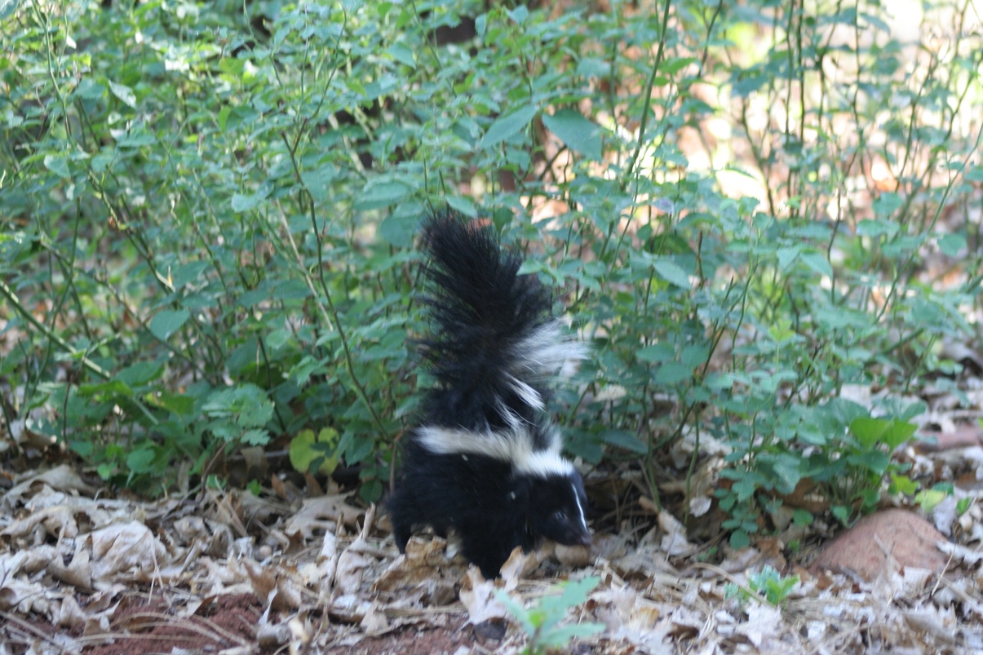
A wonderful totem

